LOW-LIGHT IMAGE ENHANCEMENT USING SPATIAL AND INTENSITY-BASED TECHNIQUES

ABSTRACT
Low-light images often suffer from poor visibility, reduced contrast, loss of details, and inaccurate color representation. These problems can affect the performance of computer vision applications such as object detection, image segmentation, surveillance, and image analysis. This project focuses on enhancing low-light images using both traditional image processing techniques and a deep learning-based approach. The traditional methods implemented include Gamma Correction, Histogram Equalization, Contrast Limited Adaptive Histogram Equalization (CLAHE), Single-Scale Retinex (SSR), and Multi-Scale Retinex (MSR). In addition, a U-Net-based convolutional neural network is trained using paired low-light and normal-light images from the LOL-v1 dataset. The model learns to transform dark images into enhanced images by minimizing the difference between its predictions and the corresponding ground-truth images. Performance is evaluated using Peak Signal-to-Noise Ratio (PSNR) and Structural Similarity Index Measure (SSIM). Among the evaluated methods, the trained U-Net achieves the best recorded performance, with a PSNR of 18.3099 dB and an SSIM of 0.7797. The results demonstrate that the learning-based approach provides better overall enhancement than the implemented traditional techniques on the test dataset.
1. INTRODUCTION
Images captured under poor lighting conditions frequently contain insufficient brightness, low contrast, and unclear visual details. Such images may make it difficult to identify objects, recognize patterns, or extract useful information. Low-light enhancement aims to improve image visibility while preserving important structural information and natural colors.
Traditional image enhancement methods modify image intensity, brightness, or contrast using mathematical transformations. These techniques are generally simple and computationally efficient, but their performance can depend on the image content and the selected parameters. For example, increasing brightness may also amplify noise, while global contrast enhancement may over-enhance some regions and leave others unclear.
Deep learning provides an alternative approach by learning enhancement patterns from training images. In this project, a U-Net architecture is used to learn the relationship between low-light images and their corresponding well-lit images. The network uses an encoder-decoder structure with skip connections to preserve spatial information and recover image details.
The main objectives of this project are:
- To implement and compare five traditional low-light enhancement techniques.
- To train a U-Net model using paired low-light and normal-light images.
- To evaluate the enhanced images using PSNR and SSIM.
- To compare the performance of traditional techniques with the deep learning-based approach.
2. METHODOLOGY
2.1 Dataset and Preprocessing
The project uses the LOL-v1 dataset, which contains paired low-light images and corresponding normal-light reference images. The our485 subset is used for training, while the eval15 subset is used for evaluation. The test set contains 15 image pairs.
Images are loaded in RGB format and normalized to the range [0, 1]. During training, random 256 × 256 crops and random horizontal flipping are used to introduce variation and help the model learn from different image regions. Images are converted into tensors in channel-first format before being passed to the network.
2.2 Traditional Image Enhancement Techniques
Five traditional methods are implemented to improve brightness, contrast, and visibility.
1. Gamma Correction
Gamma Correction is a nonlinear intensity transformation that adjusts image brightness. The output intensity is calculated as:
I_out = I_in^γ
where I_in is the normalized input intensity and γ is the gamma value. In this project, γ = 0.6 is used. Since the gamma value is less than 1, darker intensity values become brighter. This method is simple and effective for basic brightness enhancement, although it may not recover details lost in extremely dark regions.
2. Histogram Equalization
Histogram Equalization improves contrast by redistributing image intensity values across the available range. It is applied to the luminance channel after converting the image from RGB to the YCrCb color space. Only the Y channel is equalized, while the chrominance channels are retained. This helps improve brightness and contrast while reducing unnecessary changes to color information. However, global histogram equalization may produce unnatural contrast or amplify noise.
3. Contrast Limited Adaptive Histogram Equalization (CLAHE)
CLAHE enhances contrast locally by dividing the image into small regions and applying histogram equalization within each region. A contrast limit restricts excessive amplification, while interpolation helps reduce visible boundaries between regions. In this project, a clip limit of 2.0 and a tile grid size of 8 × 8 are used on the luminance channel. CLAHE can reveal local details in dark areas, although its effectiveness depends on parameter selection.
4. Single-Scale Retinex (SSR)
Single-Scale Retinex is based on the idea that an image can be separated into illumination and reflectance components. It estimates illumination by applying Gaussian smoothing to the input image and then uses a logarithmic difference to enhance details. The general formulation is:
R(x, y) = log(I(x, y)) − log(G(x, y) * I(x, y))
where I represents the input image, G is a Gaussian function, and * denotes convolution. A Gaussian scale of σ = 30 is used in this project. SSR can improve visibility and color appearance, but a single scale may not preserve all fine and large-scale image details equally well.
5. Multi-Scale Retinex (MSR)
Multi-Scale Retinex extends SSR by combining illumination estimates obtained at different Gaussian scales. In this project, the scales σ = 15, 80, and 250 are used. The method combines information from different spatial scales to improve local details, contrast, and overall illumination. Compared with SSR, MSR can provide a more balanced enhancement because it considers both fine and broad illumination variations. However, the output may still contain color shifts or noise depending on the input image and implementation.
2.3 U-Net-Based Deep Learning Model
A U-Net convolutional neural network is implemented to learn low-light image enhancement from paired training data. U-Net consists of an encoder, a bottleneck, and a decoder connected through skip connections.
The encoder extracts image features at progressively lower spatial resolutions. Its convolutional blocks use increasing channel sizes of 32, 64, 128, and 256, followed by a bottleneck with 512 channels. The decoder gradually restores the spatial resolution using transposed convolutions and combines decoder features with corresponding encoder features through skip connections. These connections help preserve spatial details that might otherwise be lost during downsampling.
A final 1 × 1 convolution produces a three-channel RGB output, and a sigmoid activation constrains the predicted pixel values to the range [0, 1]. Therefore, the network directly predicts an enhanced image from a low-light input image.
2.4 Training Procedure and Loss Function
The model is trained in Google Colab using PyTorch and the Adam optimizer with a learning rate of 0.001. Training is performed for 50 epochs. A cosine learning-rate scheduler is used to adjust the learning rate during training.
The combined loss function consists of L1 loss and an SSIM-based structural loss:
L_total = L1 + 0.5 × (1 − SSIM)
L1 loss measures the absolute pixel-wise difference between the predicted image and the reference image. The SSIM-based term encourages the network to preserve structural similarity. Combining these terms helps the model learn both pixel-level accuracy and image structure.
The training process records the loss for each epoch and displays visual comparisons of the low-light input, enhanced output, and ground-truth image. The best model checkpoint is saved at /content/low_light_results/best_unet.pt, based on the lowest recorded training loss. The lowest recorded training loss was 0.1840 at epoch 44, while the loss at epoch 50 was 0.1872. These values describe training performance and should not be interpreted as test-set metrics.
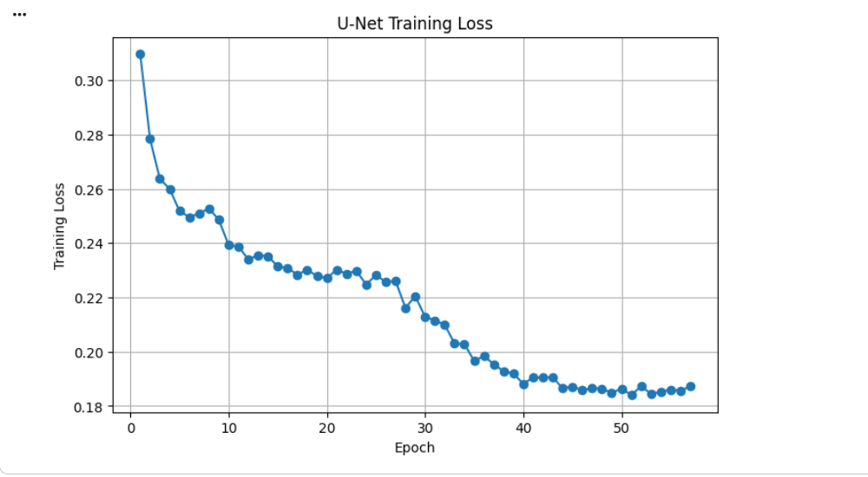
2.5 Evaluation Metrics
The enhanced images are compared with their corresponding ground-truth images using two quantitative metrics.
Peak Signal-to-Noise Ratio (PSNR): PSNR measures reconstruction quality based on the mean squared error between the enhanced and reference images. A higher PSNR generally indicates a smaller pixel-wise error.
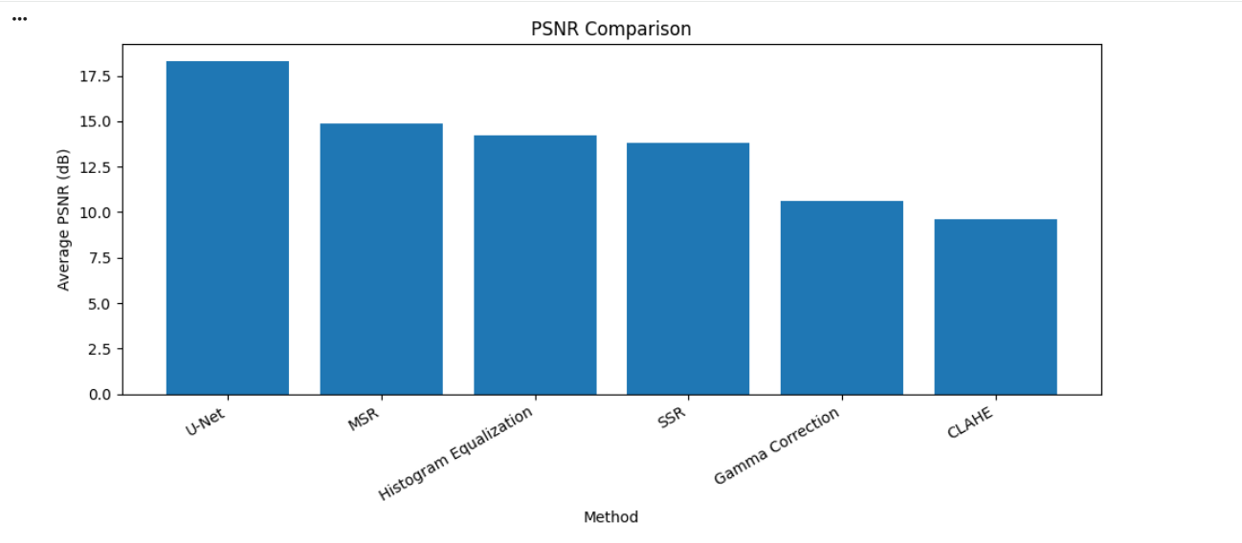
Structural Similarity Index Measure (SSIM): SSIM compares images in terms of luminance, contrast, and structural information. Values closer to 1 indicate greater structural similarity.
Both metrics are calculated for the 15 test image pairs. The resulting scores are used to compare the traditional methods and the U-Net model.

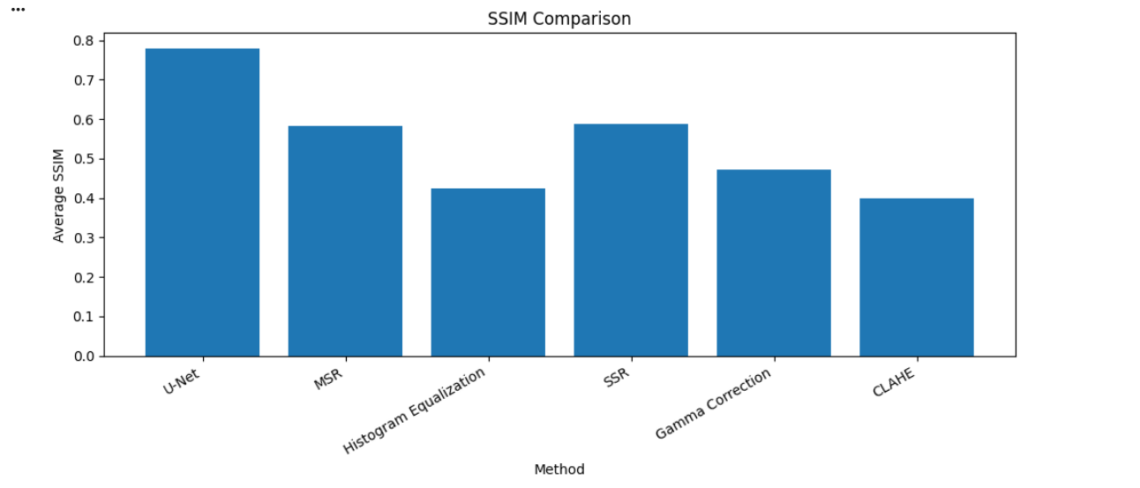
3. RESULTS AND DISCUSSION
The implemented methods are evaluated on the LOL-v1 test subset using PSNR and SSIM. The recorded results are presented below.
Method | PSNR (dB) | SSIM
U-Net | 18.3099 | 0.7797
Multi-Scale Retinex (MSR) | 14.8663 | 0.5840
Histogram Equalization | 14.2356 | 0.4252
Single-Scale Retinex (SSR) | 13.7931 | 0.5875
Gamma Correction | 10.6168 | 0.4726
CLAHE | 9.6272 | 0.3995

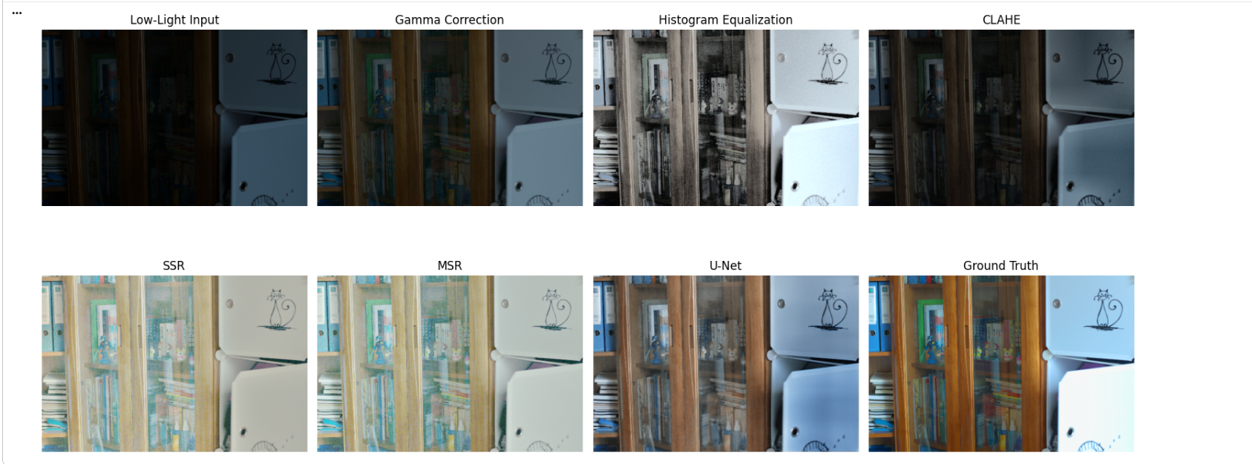

The U-Net model achieves the highest recorded PSNR and SSIM values among the evaluated methods. Its PSNR of 18.3099 dB indicates better pixel-level agreement with the reference images than the traditional techniques. Its SSIM score of 0.7797 also indicates better preservation of structural information.
Among the traditional methods, MSR achieves the highest PSNR at 14.8663 dB, while SSR obtains a slightly higher SSIM than MSR, with values of 0.5875 and 0.5840, respectively. This shows that the ranking of methods can differ depending on whether pixel-level accuracy or structural similarity is considered.
Histogram Equalization achieves a PSNR of 14.2356 dB but a lower SSIM of 0.4252, indicating that improved global contrast does not necessarily preserve the overall structure as effectively. Gamma Correction increases brightness through a simple intensity transformation, but its recorded PSNR is lower than those of MSR, SSR, and Histogram Equalization. CLAHE produces the lowest scores in this evaluation, with a PSNR of 9.6272 dB and an SSIM of 0.3995.
Overall, the results suggest that the U-Net model learns image transformations that better match the reference images than the selected traditional techniques. Traditional methods remain useful because they are comparatively simple and do not require model training. Their performance, however, is influenced by their parameters and the characteristics of individual images.
The comparison is based on the recorded evaluation results for the selected test set. PSNR and SSIM provide useful quantitative evidence, but visual inspection is also important because numerical scores do not fully represent perceived naturalness, noise, or color accuracy.
4. CONCLUSION
This project presents a comparative study of traditional and deep learning-based techniques for low-light image enhancement. Gamma Correction, Histogram Equalization, CLAHE, Single-Scale Retinex, and Multi-Scale Retinex are implemented to improve image brightness, contrast, and visibility. A U-Net model is also trained on paired images from the LOL-v1 dataset using a combined L1 and SSIM-based loss function.
Based on the recorded results, U-Net performs best among the evaluated methods, achieving a PSNR of 18.3099 dB and an SSIM of 0.7797. MSR gives the highest PSNR among the traditional techniques, while SSR obtains the highest traditional-method SSIM. These findings demonstrate the potential of deep learning for producing enhanced images that more closely resemble normal-light references.
Future work can focus on improving generalization through more diverse training images, evaluating performance on additional datasets, and assessing enhancement using further image-quality measures. The model may also be optimized to reduce inference time and support real-time applications such as surveillance and low-light computer vision.
5. TOOLS AND LIBRARIES USED
The project is implemented in Google Colab using Python. The main tools and libraries are:
- Python: Main programming language.
- Google Colab: Cloud-based notebook environment for implementation and training.
- PyTorch: U-Net implementation, model training, optimization, and tensor operations.
- NumPy: Numerical operations and image-array processing.
- OpenCV: Image processing and implementation of traditional enhancement techniques.
- Pillow (PIL): Image loading and basic image handling.
- Matplotlib: Visualization of input, enhanced, and reference images.
- scikit-image: Calculation of PSNR and SSIM metrics.
- Pandas: Organization and export of evaluation results.
The project combines traditional image processing with a learning-based model to compare different approaches to low-light image enhancement using quantitative evaluation and visual inspection.

